Rachel Hibler

Red Cohort

Costume Research

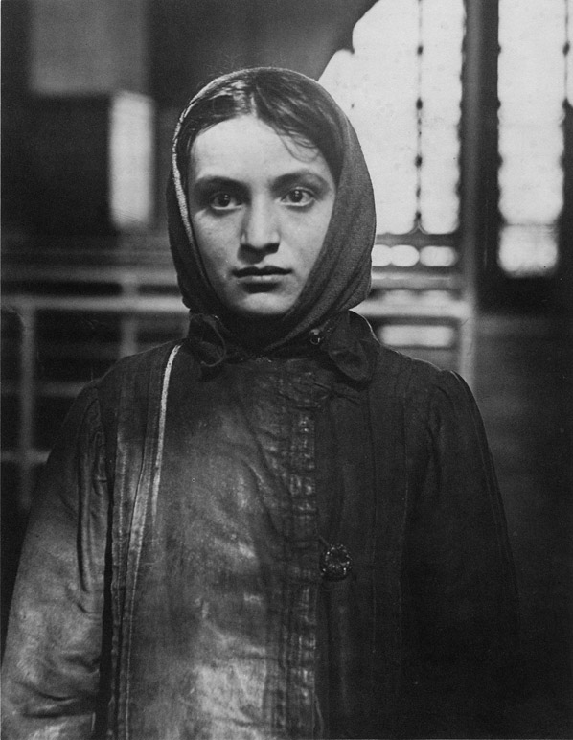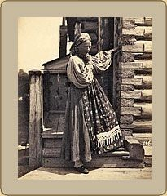Women

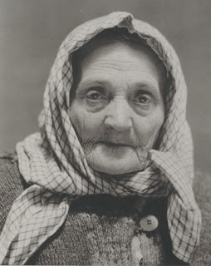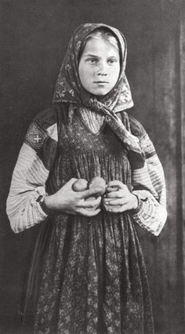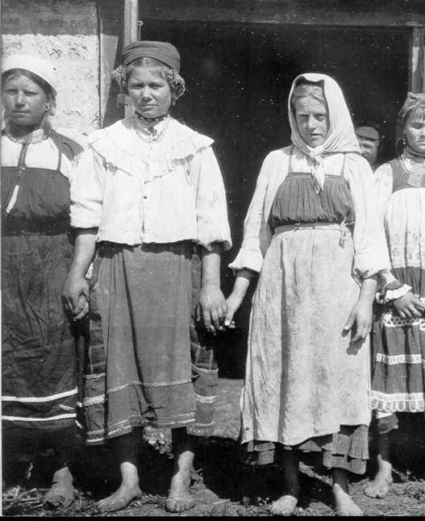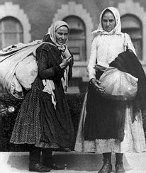

The headscarves are beautiful and are clearly tied in diverse ways. I like that for each character.

The printed apron on top right is exactly what I want.

The sweater and oversize button on bottom right is too cute.

Again, I like the patterns on the costume on top right.

The sleeves on top left are pretty and seem very utilitarian. The length of the dresses is also nice. I like the detailing on the bottom of the darker skirt.

I like bottom right as a reference for the traveling clothing and packages.

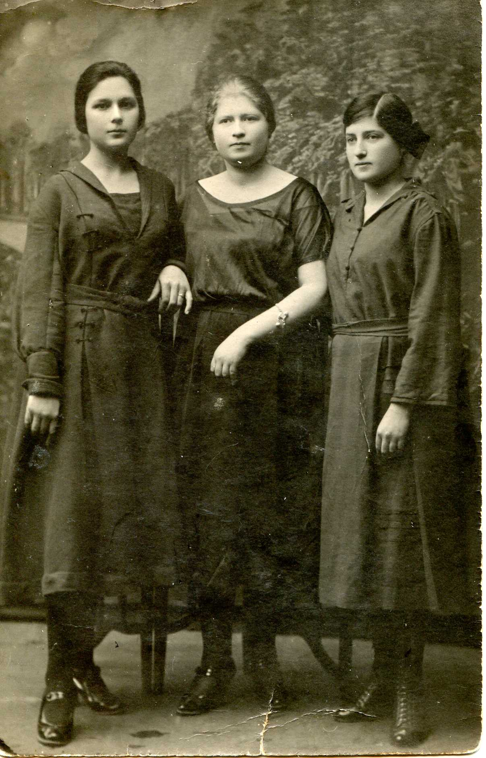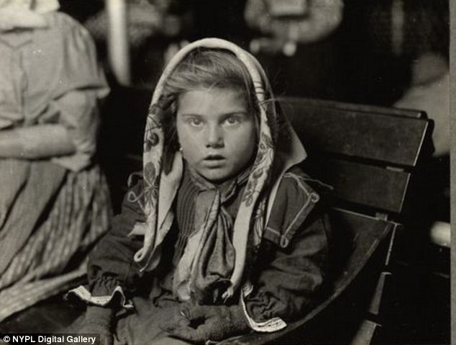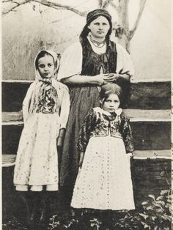

Love all the head scarves. They each seem different and have a distinct personality for the person wearing it.

I like the fabric patterns on the girls above. Gives me hope that all the costumes don’t have to be one color.

I like the draping of the dresses above left.

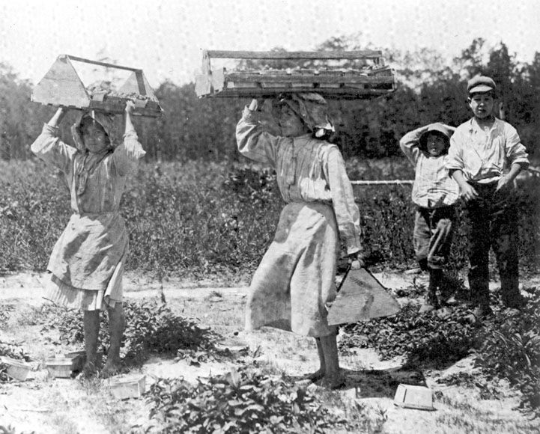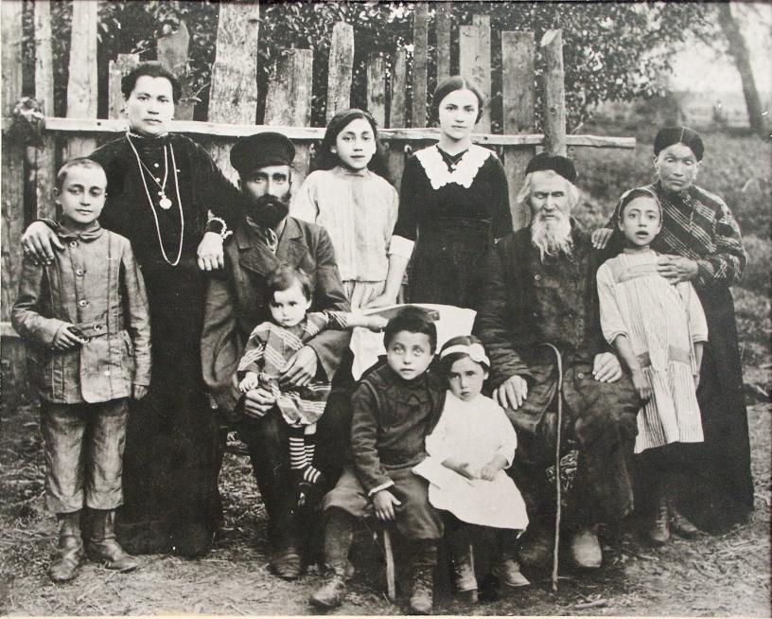

I like these two girls and how short their dresses are. Makes me think of the two youngest girls.

This family seems a bit more dressed up, this would be a good image for the wedding costumes. Add layers to their basic costume such as a jacket or shawl.

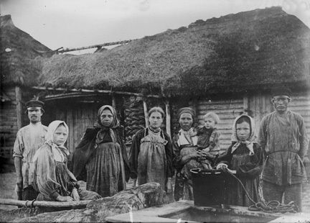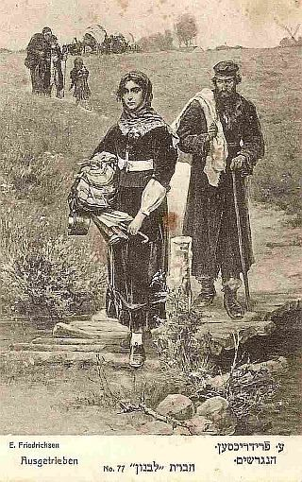

This image of a family leaving their home in the distance is very inspiring. The look of determination on the woman’s face is what I want. Her stoic acceptance of what she has lost is beautiful. She is carrying everything that is actually hers and that’s all she needs.

These girls with their head scarves and aprons are nice. I like the layers and the folding of the fabric. I like how covered up they are with their clothing.

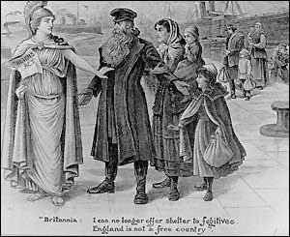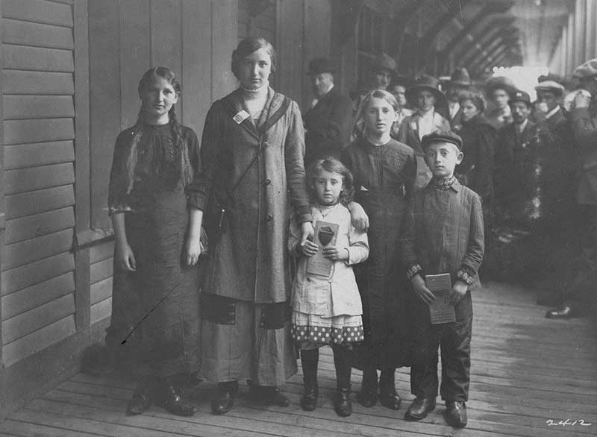

I love this picture of Jewish refugees and their traveling clothes. I like the coats and layers. The textures also seem heavy and carry the weight of the world.

I like this image of Tevye and his family being denied entrance to another home. Really gives the feeling of loss and being lost in the outer world.