Rachel Hibler

Stagecraft Period 1

Research Document: Set WOP

Fiddler on the Roof

Location: Anatevka, a village in Russia

Date: 1905, on the eve of the revolutionary period.

World of the Play: Russia

Russian city in the revolution. The buildings are old and run down

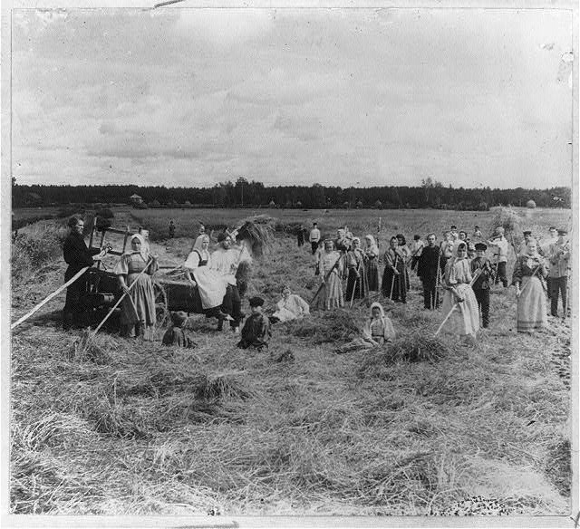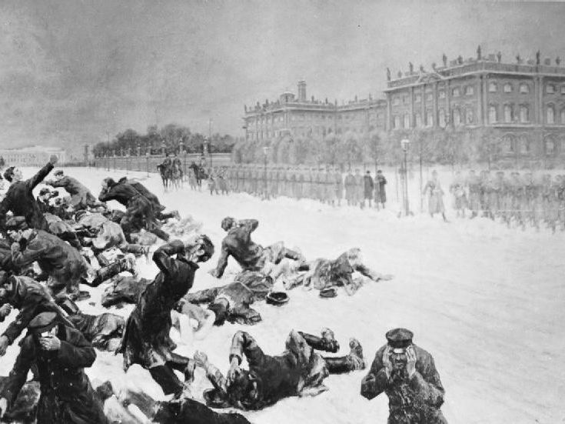

Russian countryside. The people are working in the fields. Love how open the area is.

Russian city in the revolution. The palace is beautiful and opulent, but the people are miserable.

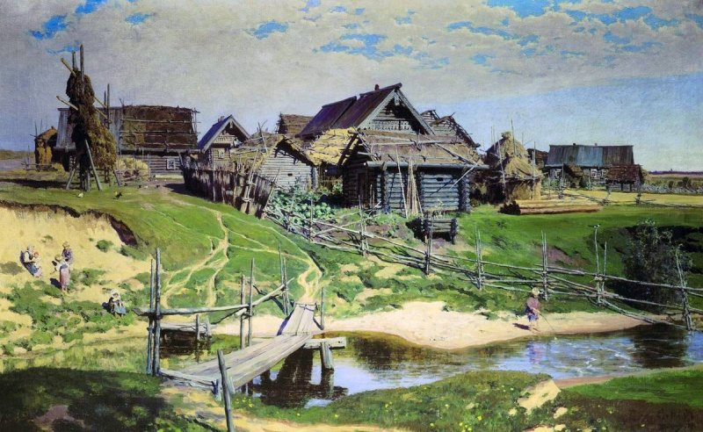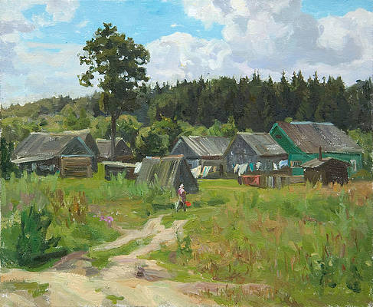

Two pics of a small town in Russia. Very run down and simple. Poor people live here. Nothing fancy, very utilitarian.

World of the Play: Anatevka

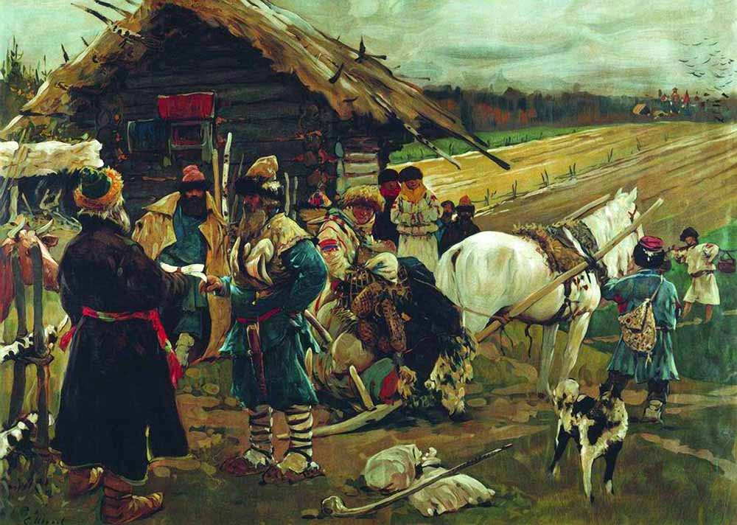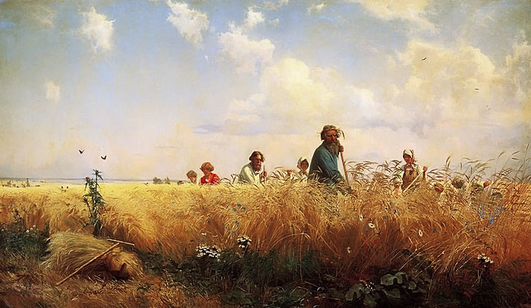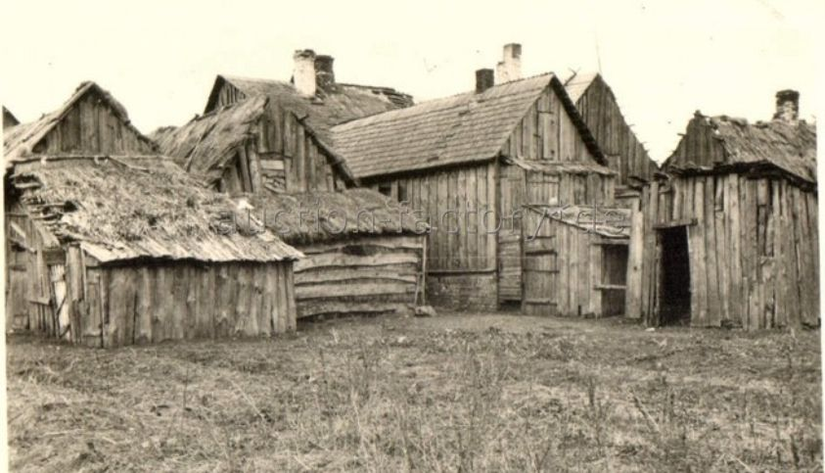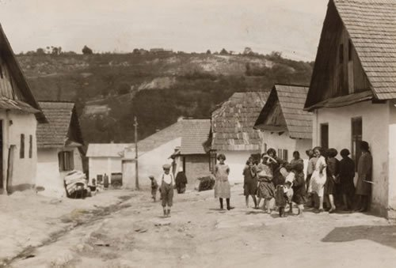

Two pics of how open the countryside is and how people interact and live.

The Jews lived in Shetls which is a Russian word for slum. The homes are packed together and very simple. Most are one room and look dilapidated.

World of the Play: Jewish Shetls

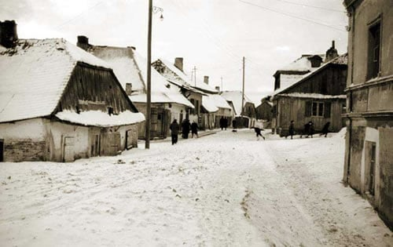

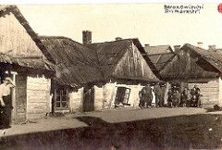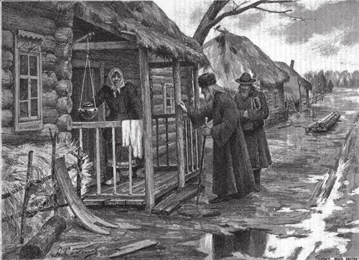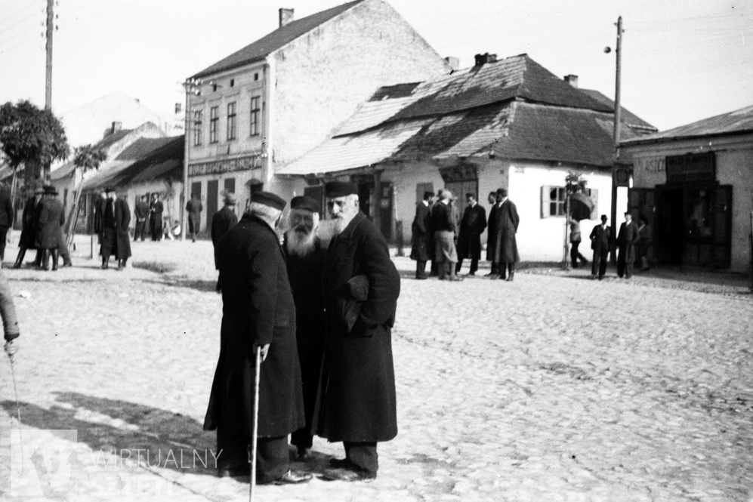

Russian village in the winter. Looks so cold and uncomfortable. People did what they had to do to survive. Really can see the desperation in the structures. The homes are leaning on each other. Good metaphor for how these people live.

The men are covered and wearing black. Hats and long coats. Religion influenced style. Beards.

World of the Play: People: Russian Jews

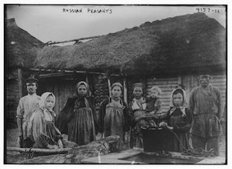

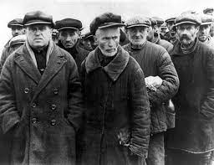

Women wear head scarves and dresses. Very covered. Warm overcoats due to Russian winter.

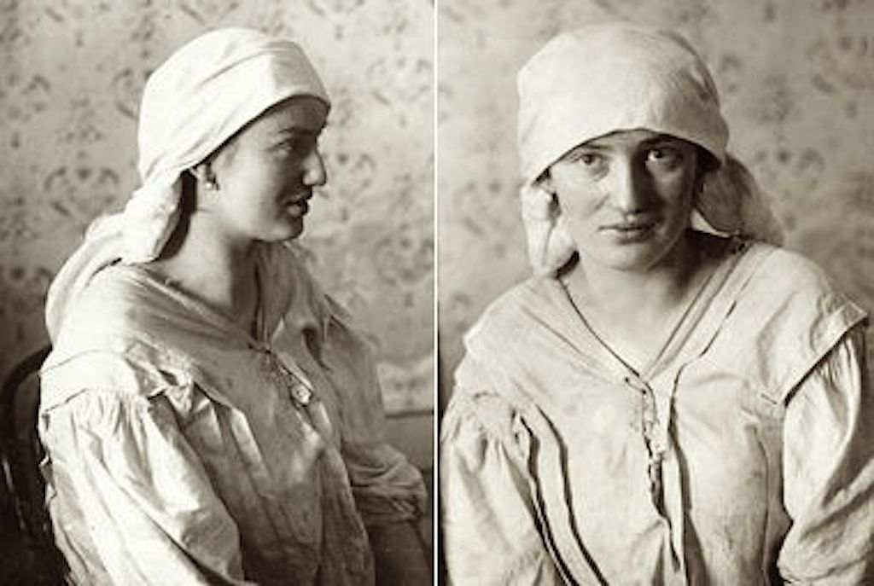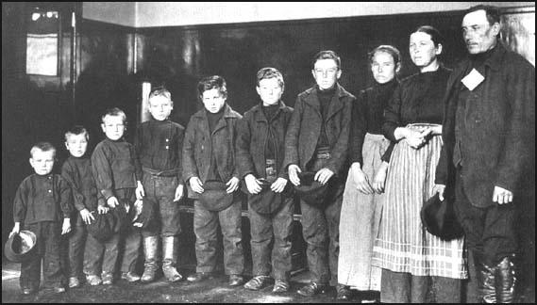

Russian Jewish family and a Russian Jewish woman. Texture of clothing is very simple, utilitarian. Clothing is designed to last.

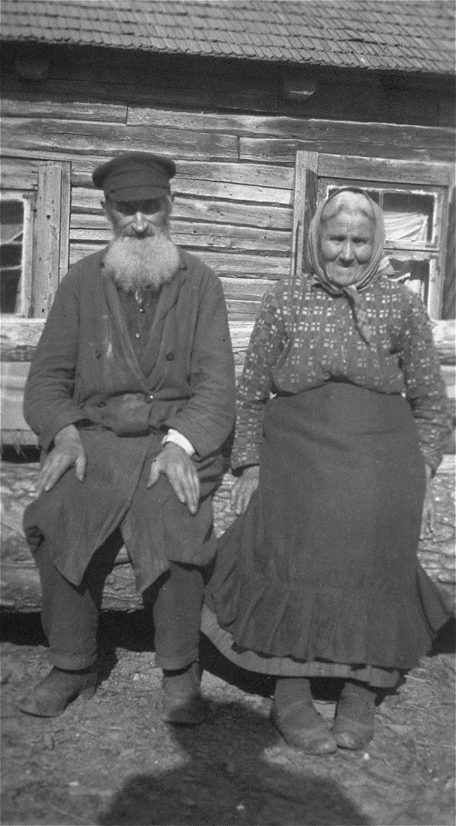

Elderly man and woman. Very covered. Lots of layers. Clothing is multipurpose and religious.

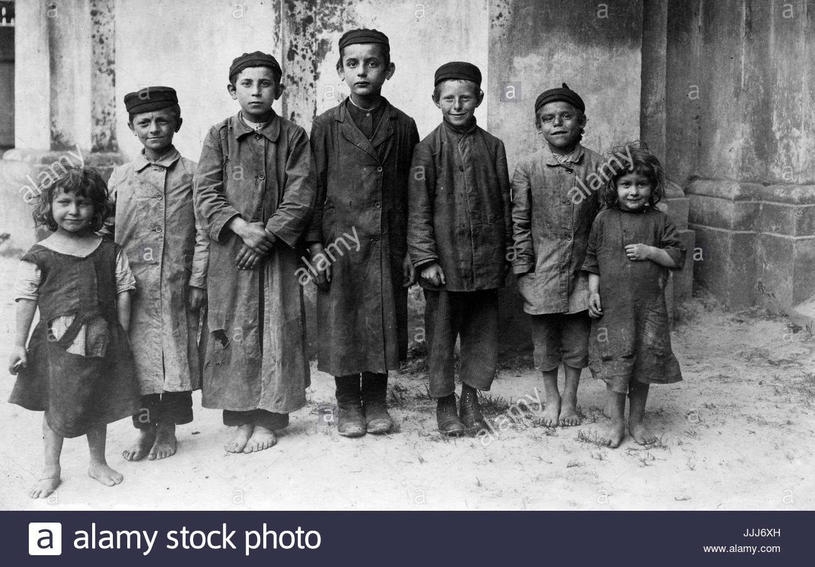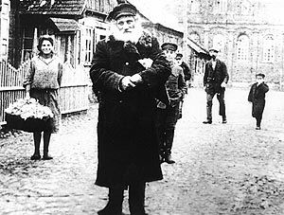

Russian Jewish children. Very covered but only two are wearing shoes. What pieces of clothing are expensive?

Elderly man and villagers.