**Greek Theatre – 7 Useful Facts for Students**

By Justin Cash September 22, 2022

**1. History**

The beginnings of Western theatre date back to Ancient Greece in the 6th century B.C. The earliest performances occurred in 534 BC at a play festival honoring [Dionysus](https://www.ancient.eu/Dionysos/), the Greek god of wine and fertility. For hundreds of years, ancient Greek theatre was performed exclusively at this outdoor play festival.

[The City of Dionysia play festival](https://en.wikipedia.org/wiki/Dionysia) in Athens was held annually at the end of March and ran over the course of several days, where plays were presented before large audiences. It was both a civic and religious festival, a community not a commercial event. The festival was organized by the principal civic magistrate of Athens. Prizes were awarded to winning playwrights in tragedy and comedy.

While there were likely several playwrights in ancient Greek theatre, the play festivals were dominated by just three writers of tragedy and two writers of comedy.

| **Tragedy** | **Comedy** | **Philosophy** |
| --- | --- | --- |
| Aeschylus | Aristophanes | Aristotle |
| Sophocles | Menander |  |
| Euripides |  |  |

**Aeschylus** (c.525-c.455 BC) wrote 70 to 90 tragic plays in his lifetime, of which [only seven survive today](https://theatrelinks.com/greek-playscripts/). He is often described as the father of tragedy. Aeschylus’ greatest innovation was the introduction of the second actor to enable face-to-face conflict. Aeschylus’ most famous works include *Agamemnon* and *Prometheus Bound*.

**Sophocles** (c.497-c.405 BC) wrote over 120 tragic plays, but [only seven of these have survived in complete form](https://theatrelinks.com/greek-playscripts/). He introduced a third actor, allowing for even more complex dramatic situations on stage. Sophocles’ most famous works include *Oedipus The King* (also known as *Oedipus Rex* and *King Oedipus*), *Antigone* and *Electra*. *Oedipus The King* is often considered by theatre historians as the perfect tragedy.

**Euripides** (c.480-c.406 BC) wrote somewhere between 92 and 95 tragedies, of which [18 or 19 have survived](https://theatrelinks.com/greek-playscripts/). He reduced the role of the chorus in his plays. Euripides’ most famous works include *The Bacchae*, *Medea* and *The Trojan Women* (also known as *The Women of Troy*).

**Aristophanes** (c.446-386 BC) wrote 40 comedies [of which 11 survive](https://theatrelinks.com/greek-playscripts/). His most famous works include *Lysistrata*, *The Frogs*, *The Clouds*, *The Wasps* and *The Birds*.

**Menander** (c.342-c.290 BC) wrote 108 comic plays later in the 4th Century BC, of which only one, *Dyskolos*, survives.

**Aristotle** (384-322 BC) was a philosopher of Ancient Greece and one of the world’s greatest thinkers. He is often regarded as the father of Western philosophy. In relation to drama, Aristotle proposed a formula for dramatic playwriting that was followed for centuries. His “Three Unities” proposed the action of a play taking place in one location over the course of a single day. This was known as the three unities of *time*, *place* and *action*.

**3. Theatre Architecture**

The circular performing space of ancient Greek theatre was known as the “[orchestra](https://www.ancient.eu/article/895/greek-theatre-architecture/)” measuring between 20 and 25 metres in diameter. The word “orchestra” means “dancing place” (“orkheisthai” = to dance, “tra” = “place”). Actors changed costumes and masks at the rear of the orchestra in the “[skene](https://www.britannica.com/art/skene)” (meaning “hut” or “tent”), a rectangular structure facing the audience.

The modern word “[scene](https://thedramateacher.com/dramatic-elements/)” derives from “skene” (pronounced sk-ee-n). Later, the skene also served to position machinery needed to raise corpses or lower gods from above. It is not clear as to whether the skene was used as scenery or not, but most plays of the period were set before a temple, palace, or some other type of building, of which the skene structure could suffice. Later, a “proskenion” was added to the front of the skene (“pro” = in front of or before), a raised narrow platform for solo performers.

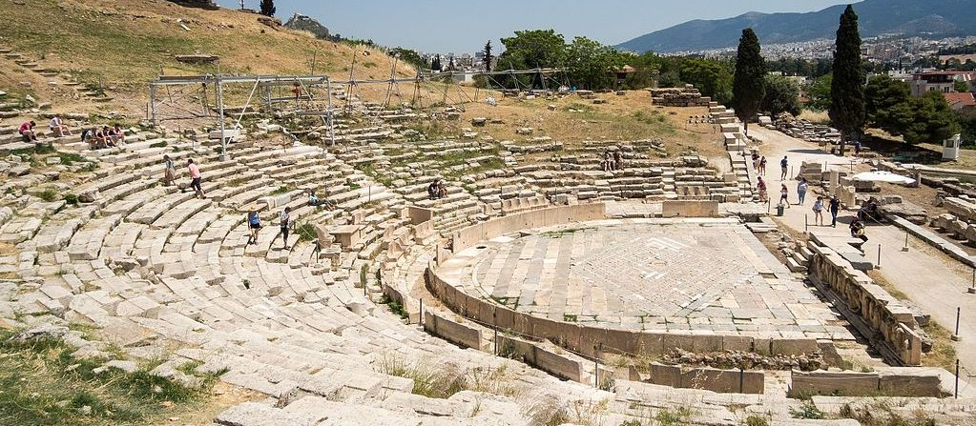Theatre of Dionysus

**4. Spectators**

The huge outdoor performance spaces of ancient Greek plays were known as amphitheaters. The Greeks called them “theatrons”, or “seeing places”. They were capable of seating between 15,000 and 20,000 spectators. Performances typically took place at the bottom of a hill, with rows of wooden, then later stone seating arranged in a semi-circle for the audience.

Actor’s voices were naturally amplified up a hill, so audiences could easily hear performers in the plays. In fact, surviving Greek amphitheaters from the 5th and 4th centuries BC, like the Theatre of Epidaurus below, are acoustically near-perfect.

Theatre of Epidaurus

**5. Acting**

All actors were male in ancient Greek theatre, though there were numerous female characters in the plays of the period. Performers typically played a large number of different roles in a single play. As the actors were small in size when viewed by a large audience up a hillside, it is likely the acting was presentational in style, with deliberately large actions and gestures, similar to those seen in modern-day operas.

Early works involved one actor and a chorus of women (played by men). There were many parts in these plays, but they were all performed by a single actor. The first actor was a performer named Thespis. This is why actors today are sometimes known as “thespians”.

The chorus in ancient Greek tragedies most likely consisted of 15 people. The chorus normally performed in unison, but was sometimes divided into two semi-choruses, perhaps speaking alternate lines or dividing up speeches. The chorus leader (choragos) occasionally spoke individual lines, though the chorus typically spoke or sang as a group. The chorus normally entered the orchestra immediately after the prologue at the beginning of the play and remained on stage until the play’s conclusion.

The chorus served many functions, chief among these being to express opinions and to give advice to characters in the drama. The chorus was sometimes seen as another spectator, reacting to the action from the side, like the audience.

**6. Music and Dance**

Music was a key ingredient of Ancient Greek theatre. It was used in conjunction with certain speeches in the plays and often during the words of the chorus. Music was rarely separated from the spoken word and when used as such, was for special effects. Musical accompaniment to the drama was commonly played on a flute. Special effects were provided by a trumpet or percussion.

Most dances in the plays of Ancient Greece expressed a particular character or situation in the plot. These included everything from religious processions to wedding dances and even frenzies.

**7. Costume and Mask**

Performers in Greek tragedies wore masks made of linen, cork or wood. Costumes changed over the centuries, though it was common for actors to wear a sleeved, highly decorated ankle-length tunic. Typical footwear was most likely a soft shoe or boot. As there was little in terms of set design or properties, the visual element of the plays was largely characterised by the use of costumes and masks.