Actor Preparedness Kit

*All actors need to be prepared with their own undergarments and makeup.*

**Base Costume**

A Base Costume is a term for all the undergarments an actor wears under their costume. All base costume colors should be neutral or skin color. Base costumes should fit snugly to the actor’s body and not shift or be seen under costumes.

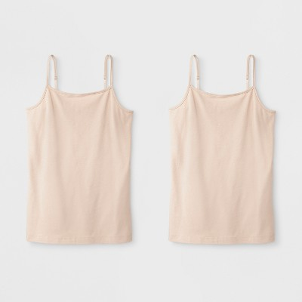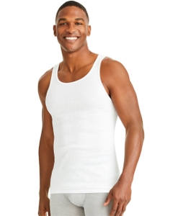Tops

* Cami/Shell
* A line shirt

Legs/Feet

* Tights
* Character shoes
  + Black or Nude

Bottoms

* Full coverage underwear
* Briefs
* 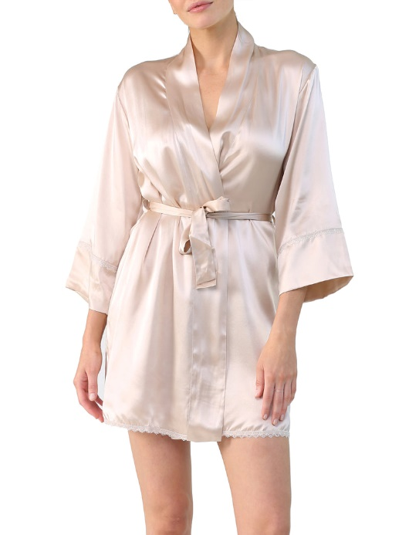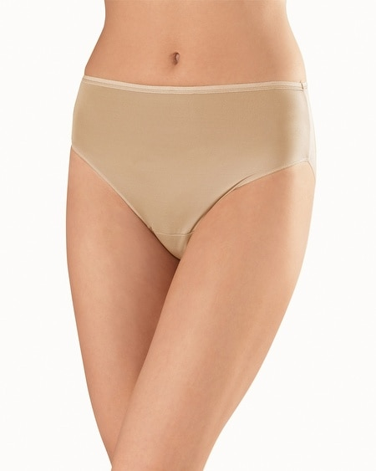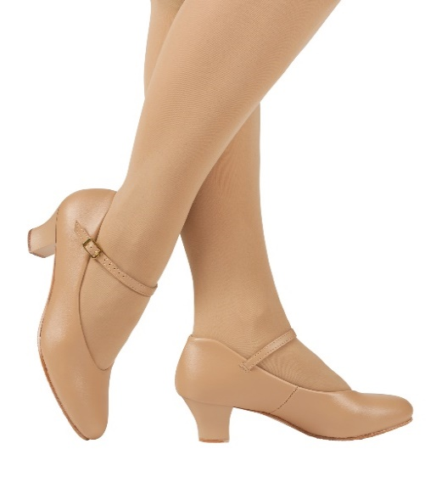Modesty shorts

**Modesty Robe**

A robe is a must for all actors. Once your base costume is on, you may not be able to get your costume on right away and you have a right to modesty!

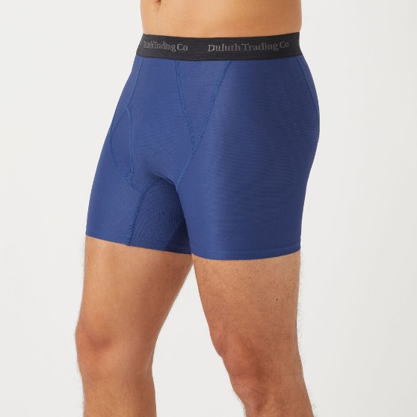

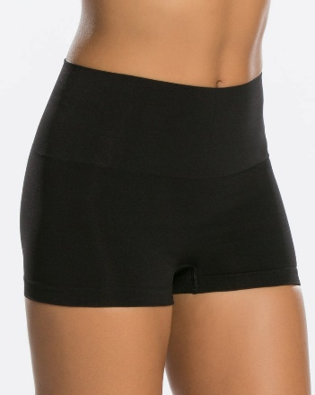

**Makeup**

The best stage makeup is Ben Nye. Every actor should invest in a basic skin color makeup kit and build their personal kit as they do shows. All actors are expected to learn how to apply their own makeup correctly

[www.bennye.com](http://www.bennye.com)

* Brushes/Applicators
* Setting powder
* Foundation
* Neutral eye shadow
* 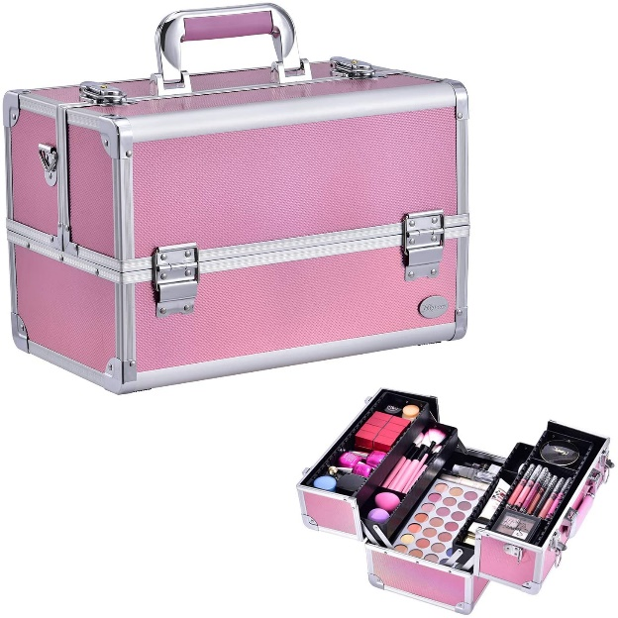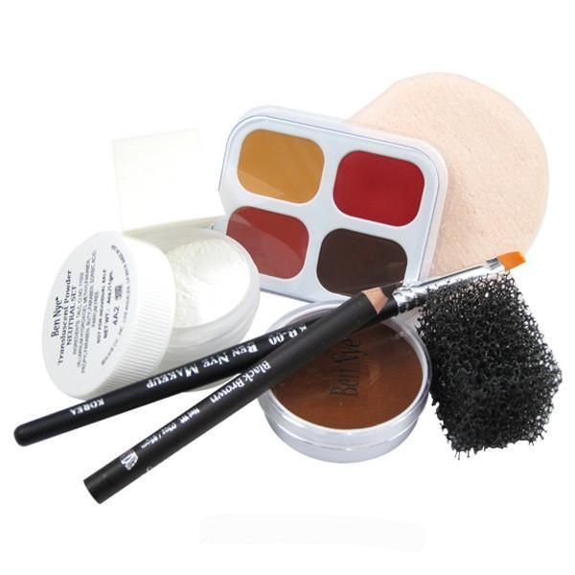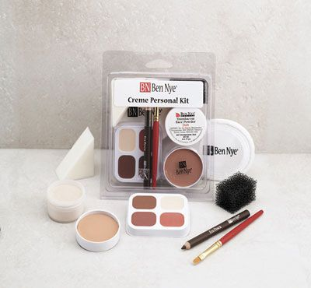Blush